Kilkenny Chamber Business Awards Photo's
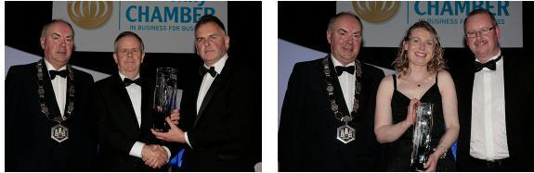
Agri Business Award Winners Craft Business of the Year
Callan Bacon Claire Molloy Ceramics
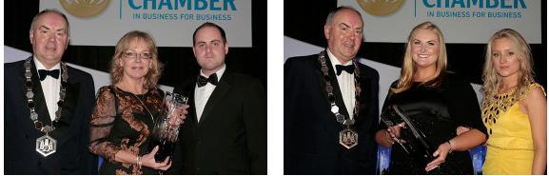

Culture & Heritage/Tourism Customer Service Excellence
Kyteler's Inn Callan Dental
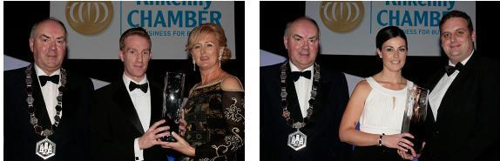
Emerging New Business Employee of the Year
Bluebird Care Geraldine Kelly Sheridan Insurance
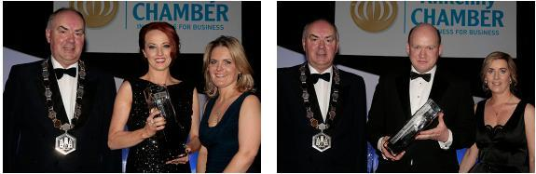
Employer of the Year Environmental Award
Rustique Hair Salon Keep Kilkenny Beautiful
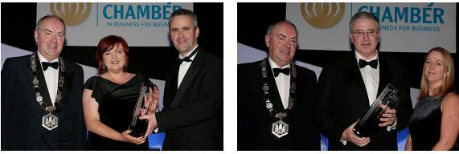
Excellence In Communications Excellence in Hospitality
Midas PR Pembroke Hotel
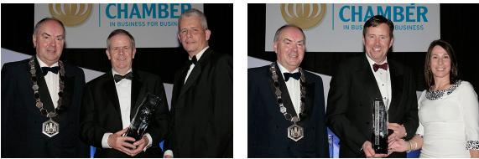
Exporter Award Family Business Award
Callan Bacon Sheridan Insurance
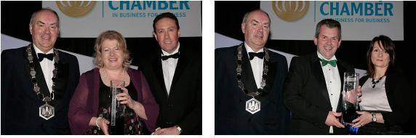
Food and Drink Producer Innovation Award
Knockdrinna Cheese Sales Pulse
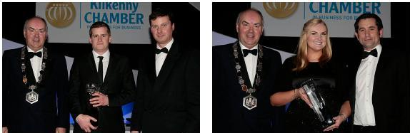
Intern In Business Award Invest In Skills
Michael Egan Rikon Callan Bacon
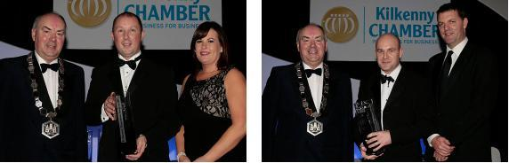
Retailer of the Year Service Provider

Caulfield's Super Valu Loughboy Munster & Leinster Cleaning Services
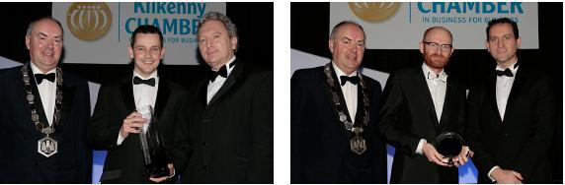
Small Business Award International Award
Brian Dunlop Architects Cartoon Saloon
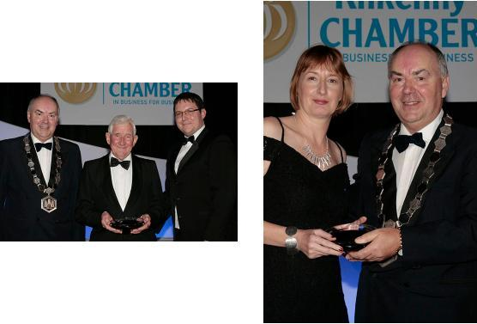
Lifetime Achievement Award President's Award
Billy Dalton Margaret Ward
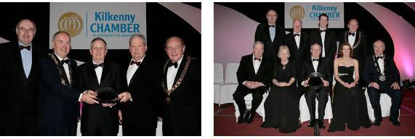
Overall Business of the Year Callan Bacon

